Docker Push and Deploy on Azure Cloud
Create a web app
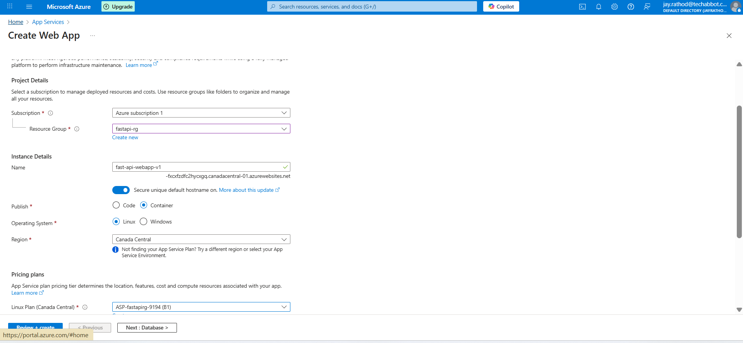
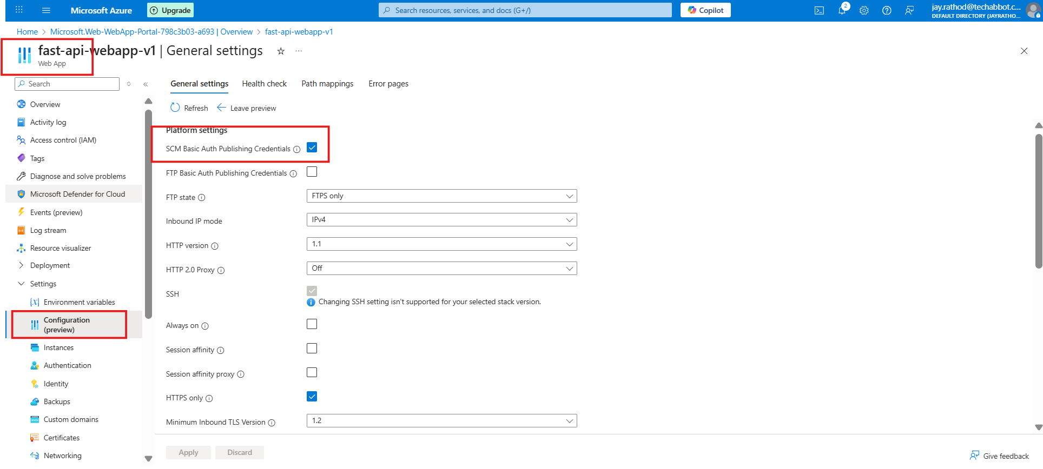
Enable SCM basic auth in the web app
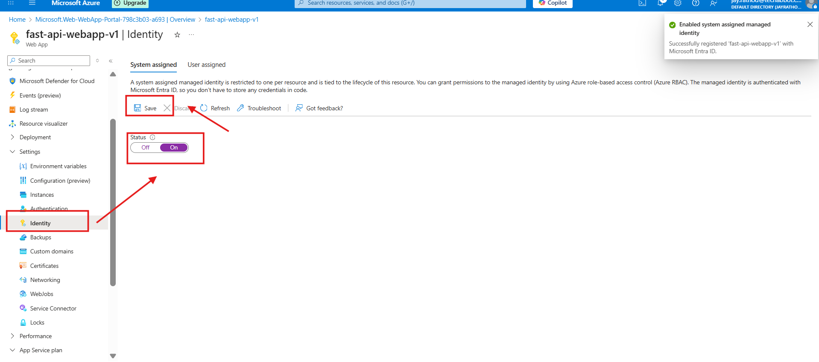
Enabled for Identity so registry access can be applied
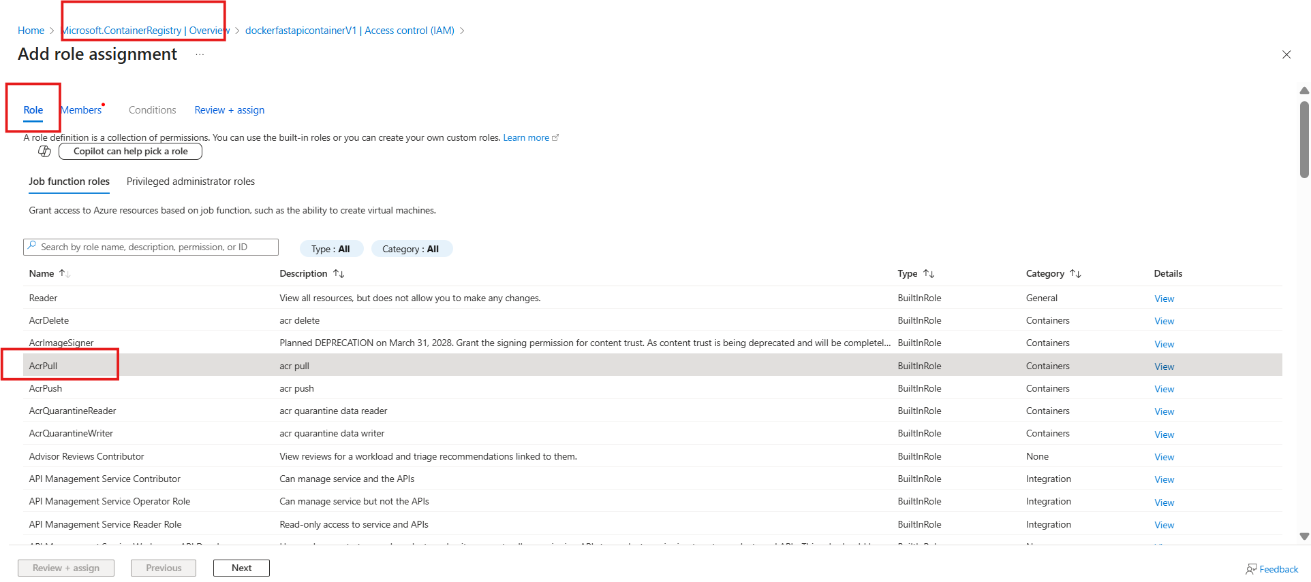
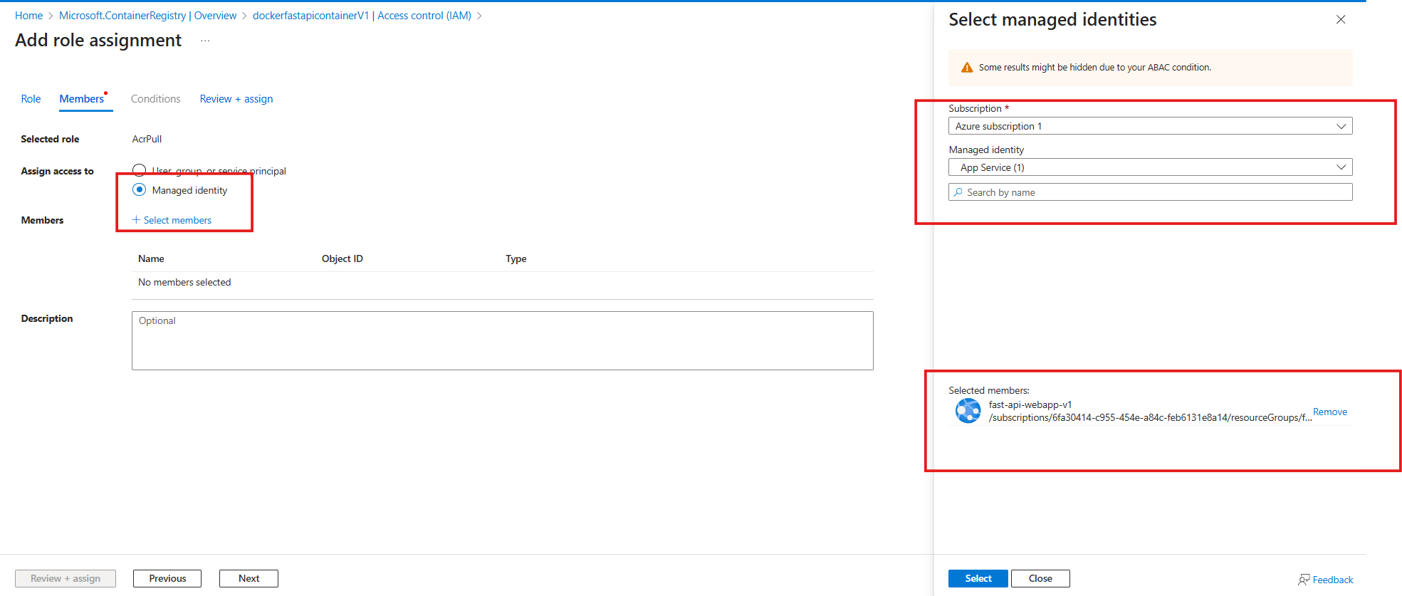
For verify
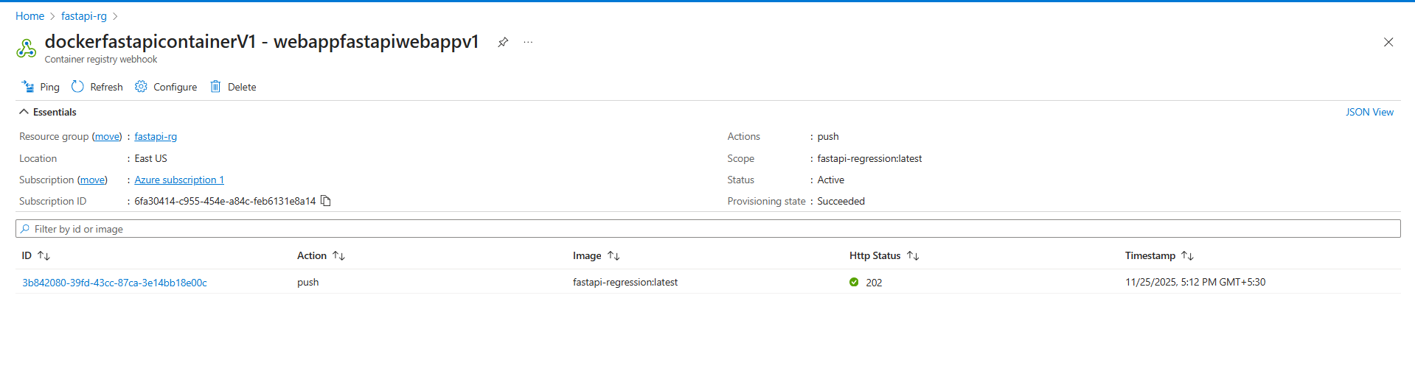

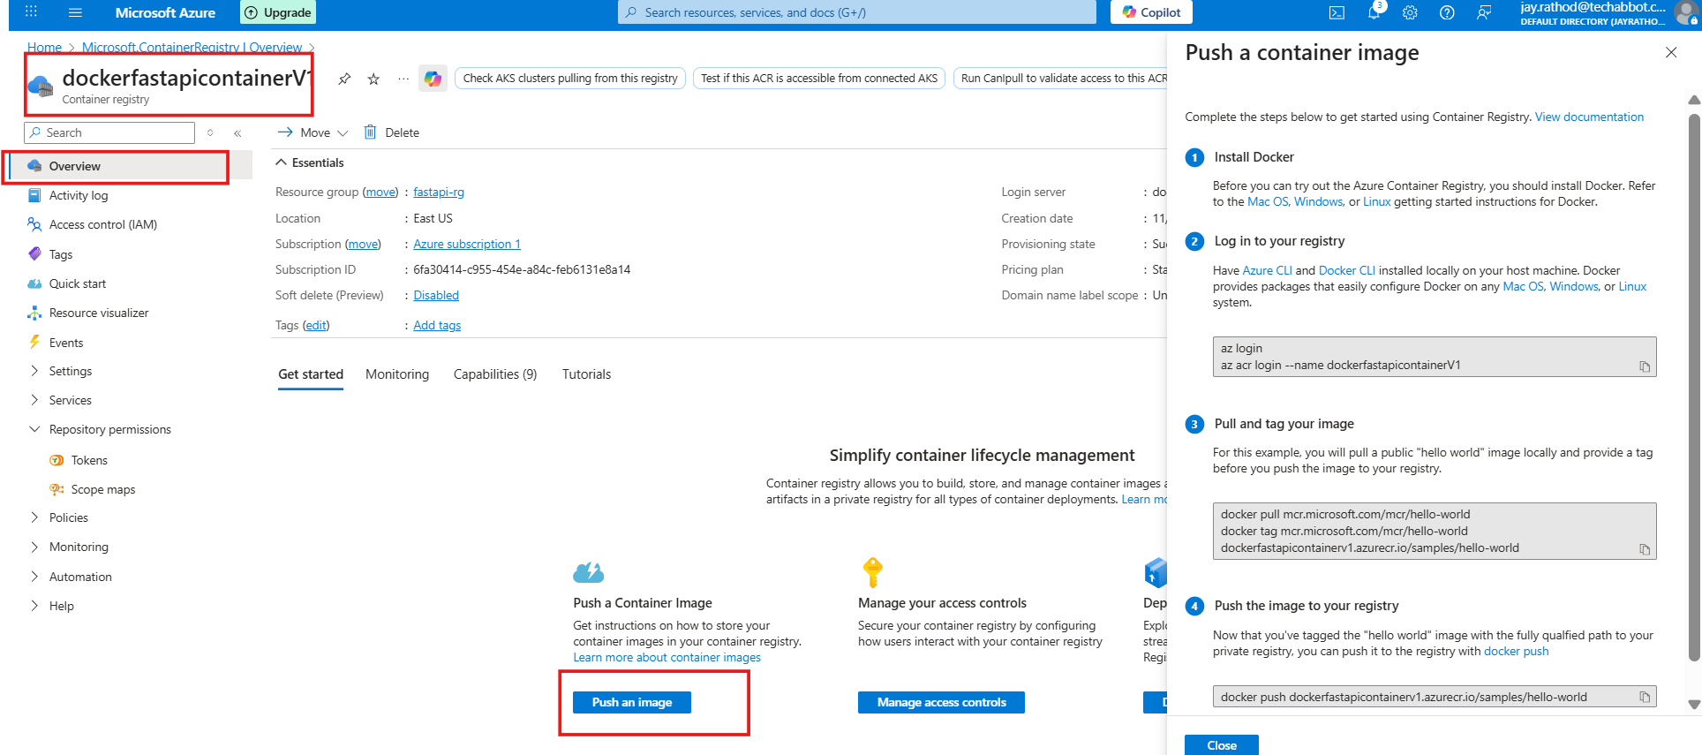
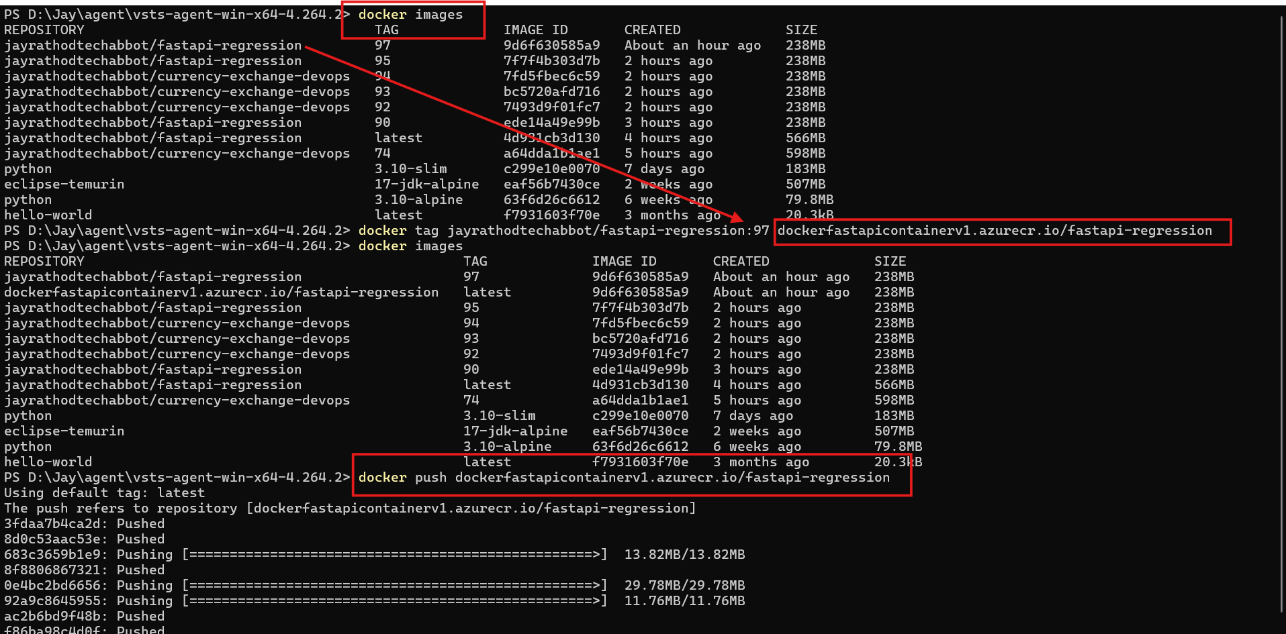
Verifying
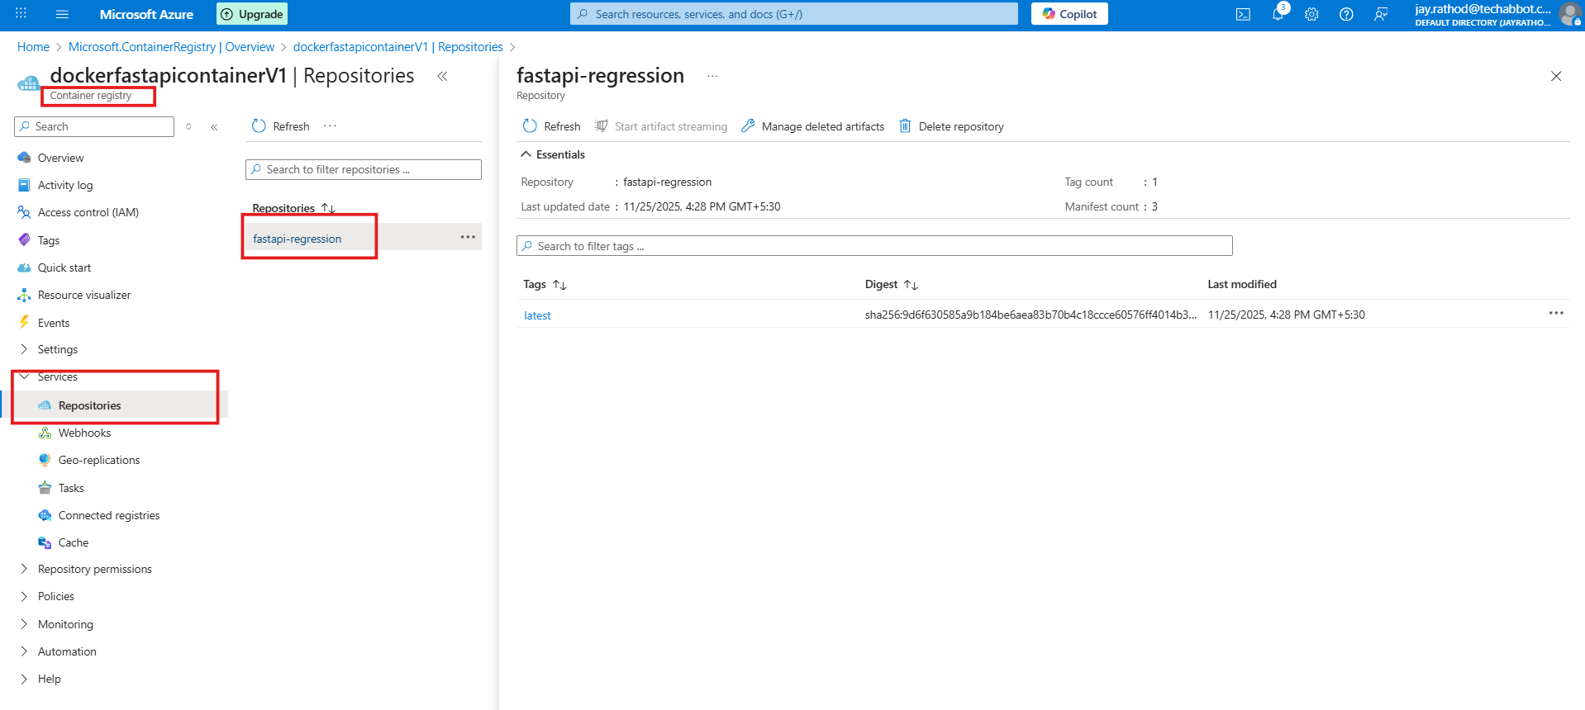
Apply changes to the deployment center in the app service
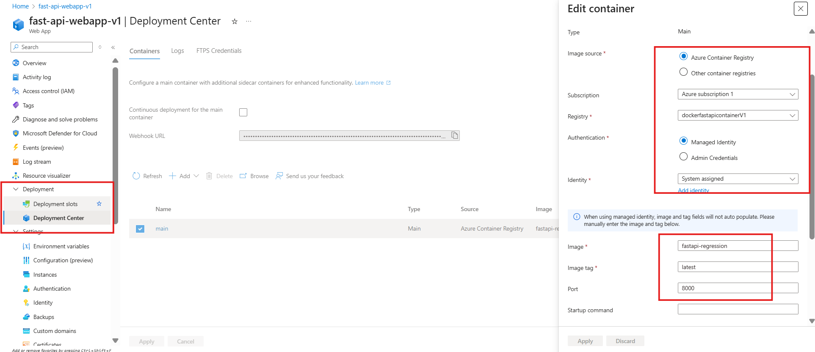

Put port : 8000
And select registery > check log >

Automatic changes in the docker file will be reflected
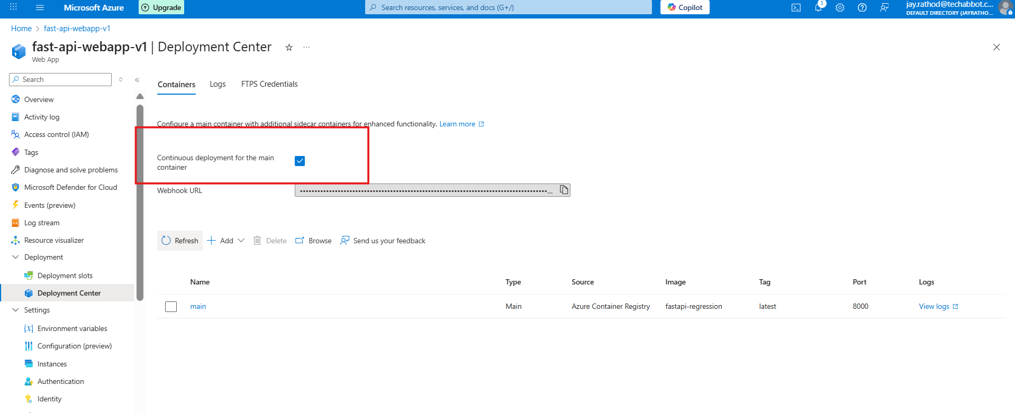

docker build -t dockerfastapicontainerv1.azurecr.io/fastapi-regression .
docker push dockerfastapicontainerv1.azurecr.io/fastapi-regression

